RhythmicTunes: Your Melodic Companion
Ideation Phase
Brainstorm & Idea Prioritization

Date | 10 March 2025
Team ID | SWTID1741162677146173
Project Name | RhythmicTunes: Your Melodic Companion
Maximum Marks | 4 Marks

Brainstorm & Idea Prioritization Template:
Brainstorming provides a free and open environment that encourages everyone within a team to participate in the creative thinking process that leads to problem solving. Prioritizing volume over value, out-of-the-box ideas are welcome and built upon, and all participants are encouraged to collaborate, helping each other develop a rich amount of creative solutions.
Use this template in your own brainstorming sessions so your team can unleash their imagination and start shaping concepts even if you're not sitting in the same room.
Reference: https://www.mural.co/templates/brainstorm-and-idea-prioritization
Step-1: Team Gathering, Collaboration and Select the Problem Statement


Step-2: Brainstorm, Idea Listing and Grouping
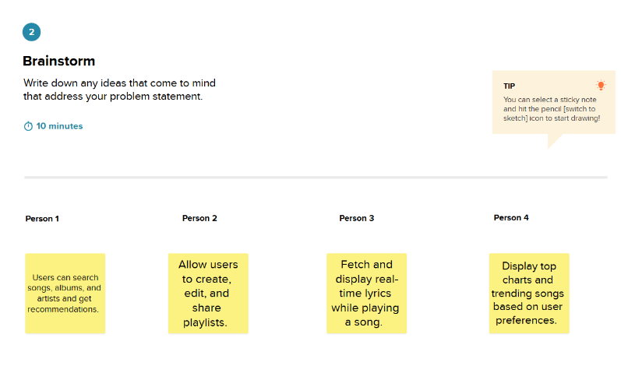
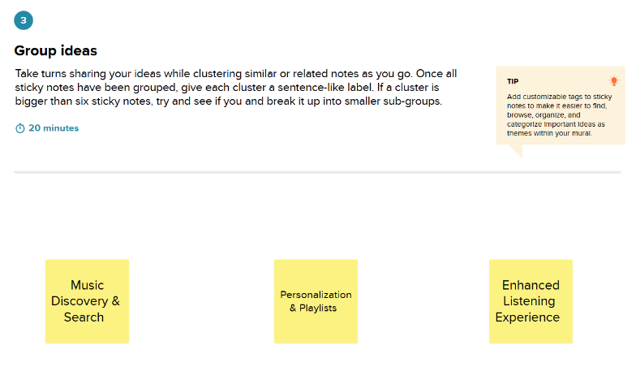

Step-3: Idea Prioritization
